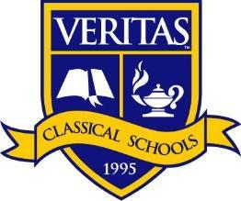
Veritas Classical School of Sylacauga
Fifth/Sixth/Seventh Grade Student Supply List 2022/2023
Please write your child’s name on all individual supplies.

Language Arts Supply List
One Glue Stick
One Pair of Scissors
Post-It Notes-3 pads of 3in x 3in (for annotating school-owned texts)
Highlighters (pack w/3-4 different colors)
Pack of ¼ Sheet Poster Board
Red Plastic Three-Pronged Folder with Pockets
Yellow Plastic Three-Pronged Folder with Pockets
2 inch binder
Dividers (5-pack or more)
Markers
Colored Pencils
Dry Erase Markers (4 pack)
Three Reams Loose Leaf Paper
One Pack of Mechanical Pencils with Led
Black Ink Pens
Pencil Bag

Science Supply List
One Plastic Folder with Brads and Pockets (green or blue)
One Pack of Loose Leaf Paper
One Pack of 5 Dividers with Pockets
Black or Blue Ink Pens
Pencils(wood or mechanical)
Multipack of Glue Sticks
Scotch Tape
10-15 Page Protectors
Spiral Mixed Media Book 7x10, 8x1, 5x7 minimum (Most likely found with art supplies)

Classroom Community Supplies
- Three rolls of paper towels
- Three boxes of Kleenex
- Five bottles of Clorox Wipes
- Two cans of Lysol or germicidal spray

Lunchroom Supplies
- Two boxes of plastic forks
- Two packs of paper plates
- Two packs of napkins

